**Container registries list by providers**

### **Google distroless containers**

<https://console.cloud.google.com/gcr/images/distroless>

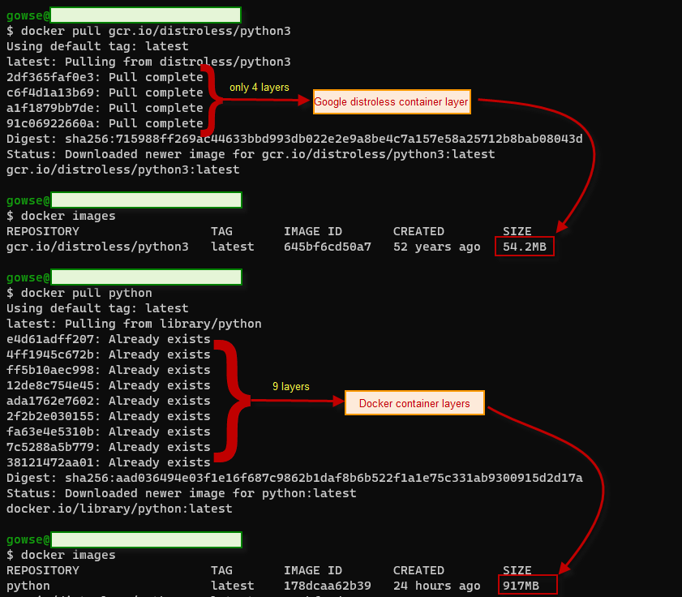

### **Google Artifact Registry (GAR)**

Google Container Registry

<https://cloud.google.com/container-registry/>

### **Azure Container registry**

<https://azure.microsoft.com/en-us/services/container-registry/#overview>

# **Amazon Container registry**

<https://aws.amazon.com/ecr/>

# **Docker Hub**

<https://hub.docker.com/>

# **Github Packages**

<https://docs.github.com/en/packages>

ghcr.io/phanatic/app:1.0.0

# **Gitlab container registry**

<https://docs.gitlab.com/ee/user/packages/container_registry/>

docker run [options] registry.example.com/group/project/image [arguments]

# **Harbor Container Registry**

<https://goharbor.io/>

# **Red Hat Quay**

<https://quay.io/search>

# **Sonatype Nexus Repository OSS**

<https://www.sonatype.com/products/repository-oss?topnav=true>

# **Contact for pricings**

1 <https://docs.aws.amazon.com/AmazonECR/latest/userguide/service-quotas.html>   
2 <https://docs.microsoft.com/en-ca/azure/container-registry/container-registry-skus#service-tier-features-and-limits>   
3 <https://www.docker.com/pricing>  
4 <https://www.docker.com/pricing>  
5 <https://cloud.google.com/artifact-registry/quotas>  
6 **Package Registry:** <https://docs.gitlab.com/ee/user/packages/package_registry/>   
7 **If you have multiple Harbor instances:**<https://goharbor.io/docs/2.3.0/administration/configuring-replication/>

